If we do a check-in option on the main screen and then when that is clicked we can do tabs for “Student” and “Staff”.

An example of tabs is below with the StartPoint, WayPoint and EndPoint, as you click on each tab it brings up the HTML for that tab on the same page. So just in the section where the pictures below are would be the location for the individual screens per tab selection (student, staff, etc).

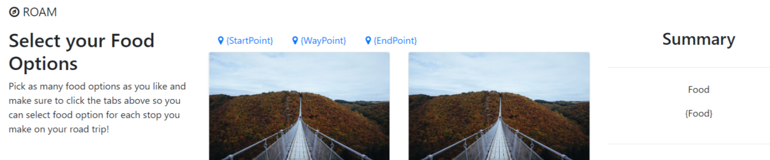

I was looking at the “Student” information and I wanted to share with everyone what I am thinking could be a start at the logic and window.

|  |
| --- |
|  |

**Student ID:**

**Enter the Student ID and then use this to lookup other information in DB that will be populated/displayed on the screen (For example):**

|  |
| --- |
| 1. **Student Name** 2. **Student Photo** – we could use photos like Derek uses for his Slack to load DB? 3. **School Staff** (teacher?) – could be a lookup in the teacher DB based on teacher employer ID tied to (or located in) the Student DB record and then the teacher name displayed on DOM. 4. **Reunification Supervisor** – Room supervisor – could be in DB as an initial default and then a dropdown or entry box, where reassignment is allowed (like we did with GIPHY assignment), maybe using an “Other” label? 5. **Reunification Point** – Room number, holding room assignment, area assignment, and could be in DB as an initial default and then a dropdown or entry box where reassignment is allowed? |

|  |  |  |  |  |
| --- | --- | --- | --- | --- |
| |  | | --- | | Received | | Transferred | | Released |   Student Status | The Student Status could be a dropdown encompassing 2 data types:   1. Student Received or Checked-In (default) 2. Student Transferred – if this is selected then another dropdown will pop-up on the window to denote the various types of student transfer methods. 3. Student Released from GCPS |

|  |  |  |  |  |  |  |  |
| --- | --- | --- | --- | --- | --- | --- | --- |
| |  | | --- | | Counseling | | Medical | | GCPS Transportation | | Law Enforcement | | Adult Pickup | | Other |   Transferred Status | The Student Transfer could be a dropdown encompassing the following data types:   1. Counseling 2. Medical 3. GCPS Transportation (students who have not been picked up and will be transported to home) 4. Law Enforcement 5. Authorized Adult Pickup 6. Other – And an entry box where reassignment entry is allowed (like we did with GIPHY assignment)? |

|  |  |  |
| --- | --- | --- |
| |  | | --- | | SUBMIT UPDATE | | The SUBMIT button will post the relevant metric data to the DB such as date and time stamps (as the basic metrics are either counts or time lapses):   1. Status “Received”, then receive check-in date/time stamp. 2. Status “Released”, then released date/time stamp 3. Status “Transferred”, then transfer date/time stamp for each transfer method:    1. Counseling Transfer date/time stamp    2. Medical Transfer date/time stamp    3. GCPS Transportation date/time stamp    4. Law Enforcement date/time stamp    5. Authorized Adult Pickup date/time stamp    6. Other – date/time stamp |